The Issue for IBISCHK6_32.exe in WinXP
This effects only for ibischk6.1.3 and beyond.
Ibischk6_32.exe is no problem when it runs in WIN 64 bit OS even it is a 32 bit program.
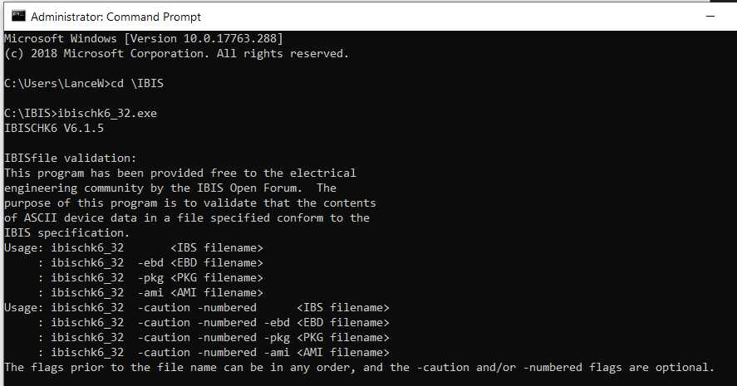

However, when it ran in WinXP (Version 5.1 - 32 bit OS), An error occurs as “The procedure entry point GetErrorMode could not be located in the dynamic link library KERNEL32.dll”.

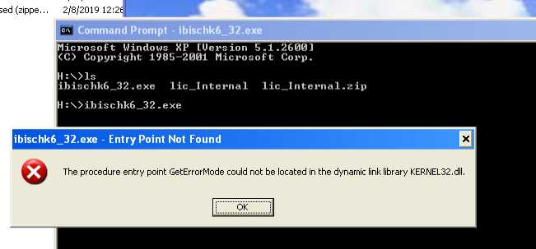

To dig it deeper, actually in Windows 32 bit OS (e.g. WinXP), it is different than in Windows 64 bit OS.
The WinXP’s kernel32.dll doesn’t contain GetErrorMode.

